DA

Lab Assignment - 4

U18CO018

Shubham Shekhaliya

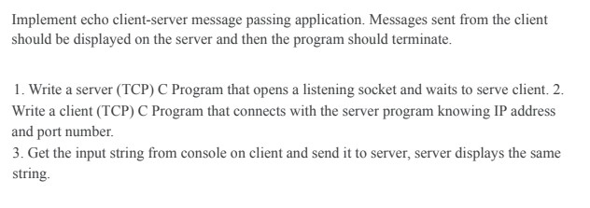

# Client.java

import java.net.*;

import java.io.*;

public class Client {

    private Socket socket = null;

    private DataInputStream input = null;

    private DataOutputStream out = null;

    public Client(String address, int port) {

        // establish a connection

        try {

            socket = new Socket(address, port);

            System.out.println("Connected");

            input = new DataInputStream(System.in);

            out = new DataOutputStream(socket.getOutputStream());

        } catch (UnknownHostException u) {

            System.out.println(u);

        } catch (IOException i) {

            System.out.println(i);

        }

        // string to read message from input

        String line = "";

        // keep reading until "Over" is input

        while (!line.equals("Over")) {

            try {

                line = input.readLine();

                out.writeUTF(line);

            } catch (IOException i) {

                System.out.println(i);

            }

        }

        // close the connection

        try {

            input.close();

            out.close();

            socket.close();

        } catch (IOException i) {

            System.out.println(i);

        }

    }

    public static void main(String args[]) {

        Client client = new Client("127.0.0.1", 5000);

    }

}

# Server.java

import java.io.BufferedInputStream;

import java.io.DataInputStream;

import java.io.IOException;

import java.net.ServerSocket;

import java.net.Socket;

public class Server {

    private Socket socket;

    private Server(int port) {

        // Create a new server socket

        ServerSocket serverSocket = null;

        try {

            serverSocket = new ServerSocket(port);

            System.out.println("Server is running on port " + port);

            // Wait for a client to connect

            socket = serverSocket.accept();

            System.out.println("Client connected");

            DataInputStream in = new DataInputStream(new BufferedInputStream(socket.getInputStream()));

            String line = "";

            // reads message from client until "Over" is sent

            while (!line.equals("Over")) {

                try {

                    line = in.readUTF();

                    System.out.println(line);

                } catch (IOException i) {

                    System.out.println(i);

                }

            }

            System.out.println("Closing connection");

            // close connection

            socket.close();

            in.close();

        } catch (IOException e) {

            e.printStackTrace();

        }

    }

    public static void main(String[] args) {

        int port = 5000;

        // Create a new server socket

        Server server = new Server(port);

    }

}

# Client

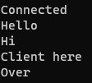

# Server

